# Eternas Game Program

You are expected to implement the software of the simplified rules of the game "Eternas".

### **Game rules**

* There are 8 wooden sticks and 32 beads (16 white, 16 green) in the game.
* The game is played by 2 players (white and green).
* The first player to start the game is always the white player.
* The bar where each player will place their bead is determined randomly. (User input
* will not be taken.)
* The first player to place 4 beads of their own color on a stick wins the game.
* No winning player during the game (as a result of placing all 32 beads)

the game ends in a draw.

The wooden sticks in the game will be implemented using the Stack data structure. Each step in the game will be listed on the screen until the game is finished.

When the game is over, the player will be listed on the screen, if there is a winner, or the draw status.

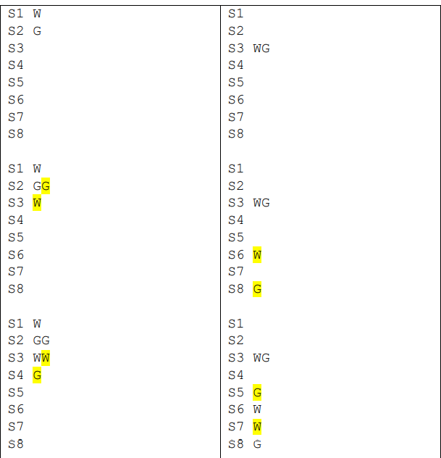Sample Outputs:

